**5-year EICR testing (power switch-off) - 'Social Studies' area**

The 5-yearly Electrical Installation Condition Report (EICR) testing is now due to be undertaken to ensure compliance with electrical requirements, and contractors from Trinity Electrical will be on campus to carry out the works. These works will involve turning off the power in each location. The works have been scheduled out of standard office times to cause as least disruption as possible to staff and students working and studying.

If you need to request an alternative date or time for the testing in your area, please let us know as soon as possible, and we will make alternative arrangements.

Testing will take place during the evenings throughout the week commencing Monday 14 July, in the area outlined on the map below:

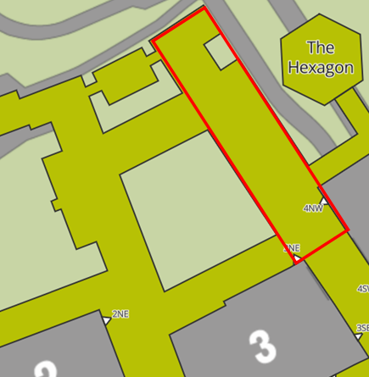

The work will involve extensive testing of the fuseboards, switcher gear, final circuits, and visual inspections for damage and overheating. Each floor will be tested individually. Emergency lighting will remain in place throughout the works.